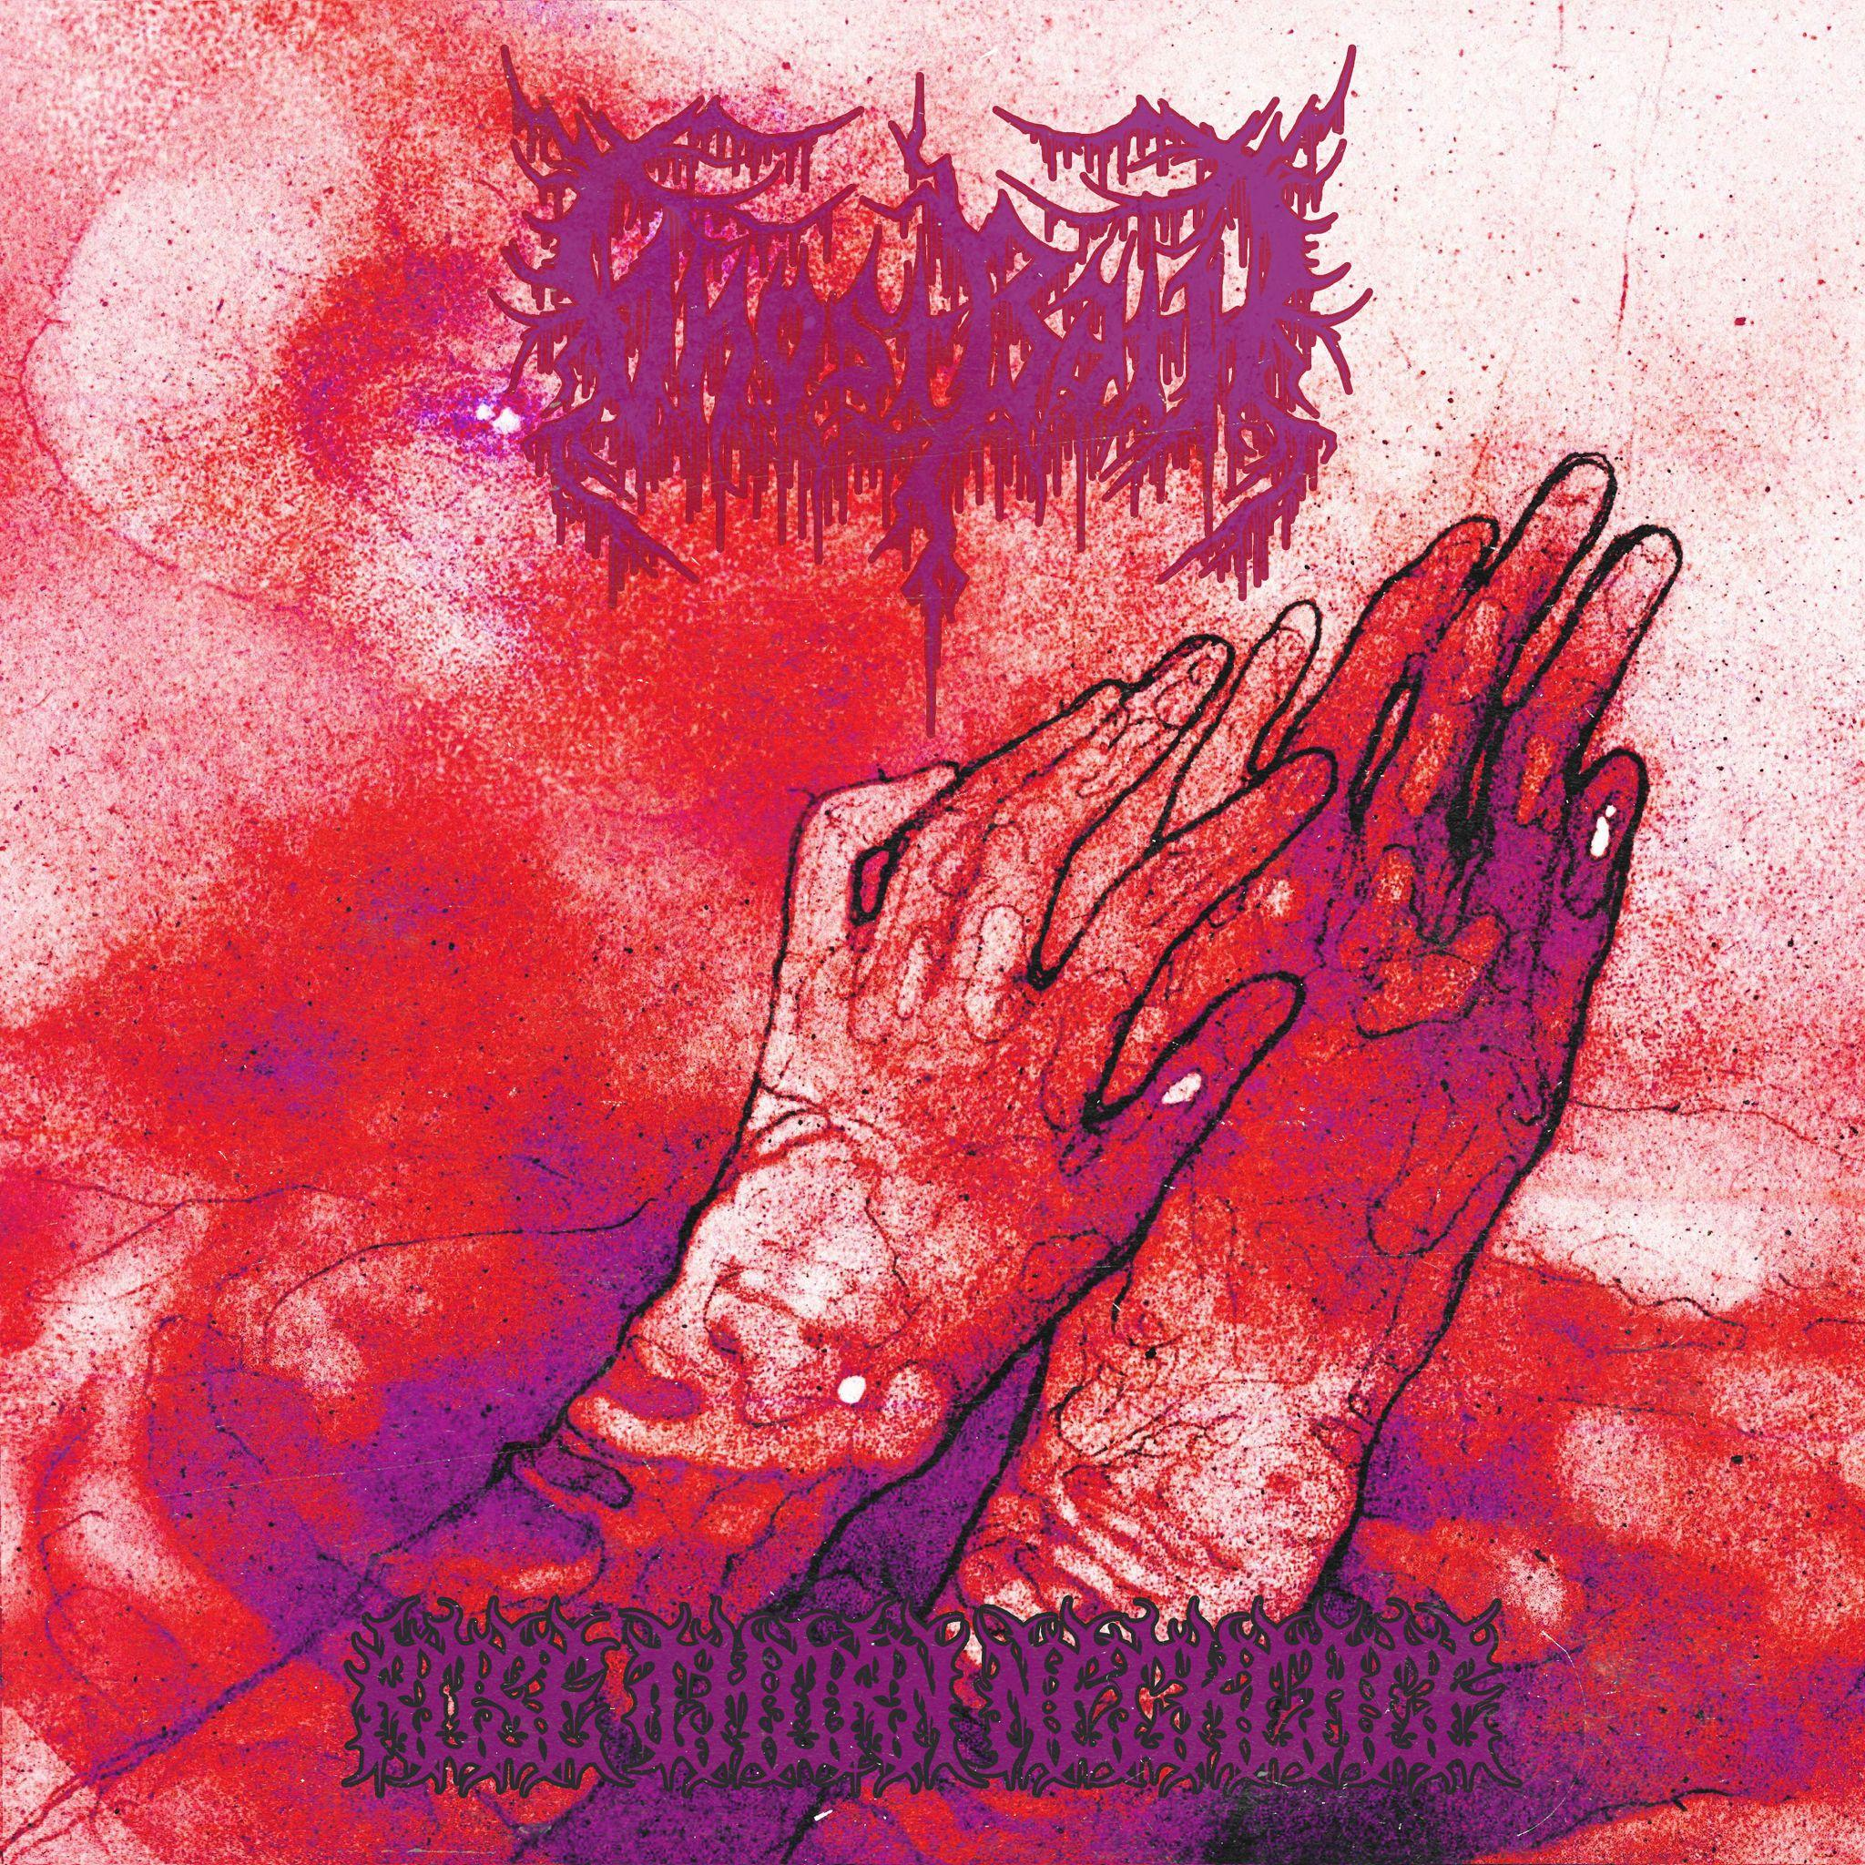

**GHOST BATH**

*Rose Thorn Necklace*

*Release Date:May 9, 2025*

|  |  |
| --- | --- |
| **Line up:** | **GHOST BATH online:** |
| **Dennis Mikula** | Vocals, Guitars, Bass, Piano, Synth  **Mike Heller** | Drums (session) | www.facebook.com/blackghostbath/  www.instagram.com/ghostbathofficial  www.youtube.com/GhostBath  www.x.com/GhostBath  www./lnk.bio/ghostbath |
|  |  |

Depressive black metallers **GHOST BATH** have emerged from beyond the veil with their new album, ***Rose Thorn Necklace***, through long-time partner **Nuclear Blast**. Free from the ***Moonlover***-***Starmourner***-***Self Loather*** conceptual trilogy, sole proprietor **Nameless** (aka **Dennis Mikula**) explores the most intense and introspective **GHOST BATH**’s oeuvre, advancing with blackened blasts and melancholic movements while moving his only child forward into the unknown. Hoisted into the firmament by the shimmering ‘**Vodka Butterfl**y’ and the dissonant bliss of ‘**Well, I Tried Drowning**’ on one end and lowered into **Mikula**’s personal abyss with ‘**Dandelion Tea**’ and the riveting title track on the other, ***Rose Thorn Necklace*** is absolute danger and haunting beauty.

“*We’ve finally gotten back into full swing with touring since the pandemic*,” says **Mikula** of the three-year gap between ***Self Loather*** and ***Rose Thorn Necklace***. “*It took a little while, but now we are back on schedule with at least 3-4 full runs a year, where I like to be. When I’m not on tour, I usually stay in isolation as much as possible. I don’t leave my house for weeks on end sometimes. I manage the band, so it keeps me busy with everything on the backend: design and artwork, writing music and lyrics, setting up tours and all of the work that entails, merch and webstores, our websites and socials, and a ton more.*”

Despair, isolation, disgust, and antipathy are the beating corrupt heart of ***Rose Thorn Necklace***. Indeed, the lyric lines in ‘**Well, I Tried Drowning**’ attest: “*Cut my throat, while I’m drowning in my sleep / I’m wide awake, I smile red as you’re watching me / Let me gargle, choke on my own blood / Forever gone, eyes glazed as my lungs flood*.” **GHOST BATH**, in their 12th year of existence, are not in the business of softening the edges. Rather, the frontman is leaning more toward his antisocial traits, serrated like a rusty knife yet beautifully honed over years of toil. From the title track, featuring **Mikula**’s signature multi-headed vocal anguish and brutality, to ‘**Dandelion Tea**,’ where **GHOST BATH** dig deeper into haunting grooves and gravestone melodies, ***Rose Thorn Necklace*** transcends.

“*I set out to really explore some disturbing things in the lyrics, the music, and the artwork*,” **Mikula** says. “*As always, I try to tie all of those together as much as possible. I began this one with a guitar riff. Then write down some ideas, and back and forth for a bit until the concept was formed. I had all these terms swirling in my head and all these disgusting ideas. The real trick was to try not to hold myself back. I wanted to make something depressive with despair, lavish, gothic, grotesque, gross, and visceral as some of the guiding themes*.”

The product of that expedition can be heard throughout ***Rose Thorn Necklace***. Whether it’s the contemplation of ‘**Thinly Sliced Heart Muscle**,’ the creepy out-of-tune sonics of ‘**Stamen and Pistil**,’ or the inner-mind crush of ‘**Throat Cancer**,’ this isn’t deceit but an open invitation into **Mikula**’s sordid universe and negative thought patterns. His main goal was to be as uninhibited as possible, to unbridle ugliness, nastiness, and grotesquery in their purest forms. The process to ***Rose Thorn Necklace*** wasn’t pretty and was filled with long hours, blackouts, and endless reformulation. Truly, the definition of insanity is insanity itself.

“*After returning from the worst tour I had ever been a part of with the band, being physically ill for over two months straight, I fell into extreme depression*,” **Mikula** says. “*The only way I know how to cope with that is to create and make art. So I got my guitar out and went insane in a way. I went from 12 hours in my office to 16 hours minimum. I became obsessed and recorded and re-recorded parts for months. When I presented them to the band, they all seemed on board, but our drummer at the time said he didn’t connect with them emotionally. We parted ways with him, and I continued. I’ve had whole bands quit on me when showing them my ideas and music. My entire lineup left when I showed them the very first EP [Ghost Bath, 2013], which is why I was solo for a while. So, I don’t blame him. I don’t think my fucked up music and lyrics are for everyone*.”

Certainly, **Ghost Bath** is ever-changing. On-stage, **Mikula**’s team includes **Tim Church** (guitars), **John Olivier** (guitars), and **Josh Jaye** (bass). In the studio, especially for ***Rose Thorn Necklace***, drummer **Mike Heller** was brought on board to help realize **GHOST BATH**’s sonic visions. MALIGNANCY/RAVEN/ex-FEAR FACTORY skinsman elevated **Mikula**’s unbridled, depressive songcraft, recording his parts and his **Heaven and Heller Studio** in Los Angeles, California. The tone set by **Mikula**’s home recordings and Heller’s punishing drums is denser, grimmer, and yet more atmospheric, as heralded by ‘**Vodka Butterfly**,’ ‘**Well, I Tried Drowning**,’ ‘**Dandelion Tea**,’ and album capper ‘**Throat Cancer**.’

“*I don’t think it was a conscious decision [to self-record]*,” says **Mikula**, who wrote and recorded in tandem. “*It just sort of happened. At the end of the day, keeping what I had written in such darkness was the right move instead of taking everything I wrote and recording and trying to reproduce it in some studio. This felt more honest and raw to me. I don’t know if I could have conjured up the thoughts and pain it took to record everything at home. I definitely didn’t want to relive it. The writing and recording happened at the same time—it was hell. Physically and mentally, it damaged me, mostly brought on by myself. I wanted to die most days, but instead, I channeled every ounce of energy I had into plucking strings and screaming into a microphone alone in my office. Then I drank until I passed out and did it again for months*.”

**Mikula** discovered Latvian artist **Ksenija Tarasova**, whose own interest in visualizing trauma and life after it, and she has been awarded accolades in the art world in Riga. Her piece for ***Rose Thorn Necklace*** wasn’t commissioned specifically for **GHOST BATH**, but the emotional connection felt right. Like **Mikula**’s music, he wants listeners to feel the artwork as part of the overall experience. From time immemorial, this has always been a meaningful symbiotic relationship. From THE VELVET UNDERGROUND’s ***The Velvet Underground & Nico*** (1967) and THE ROLLING STONES’ ***Sticky Fingers*** (1971) to DARKTHRONE’s *A* ***Blaze in the Northern Sky*** (1992) and SHINING’s ***V: Halmstad*** (2007), the visual prompts of the cover art aren’t just clues but a defined roadmap to the music and expression underneath it.

“*Like with all of our covers, I like to find a piece that is already created for its purpose and not specifically made for an album cover*,” **Mikula** says. “*So, after a ton of searching, I discovered Ksenja’s work. I could feel the emotion and the pain in the pieces. I knew right away that this would be a perfect fit. Like with all art, if the artist has an aura, most people can tell right away. No need for overthinking*.”

**Mikula** says fans need not interpret his music and art at face value. He’s not dictating anything other than what he’s experiencing, and usually, the first reaction is the correct reaction to Ghost Bath and their new album, ***Rose Thorn Necklace***. But he does hope that some of the initial sensations to emerge after run-ins with ‘**Vodka Butterfly**,’ ‘**Well, I Tried Drowning**,’ ‘**Dandelion Tea**,’ and the title track are nausea, depression, fear, and confusion. Look for **GHOST BATH** on the road with UADA in Europe, SWALLOW THE SUN/ HARAKIRI FOR THE SKY in the US, their Black Metal Chaos Festival appearance in Mexico, and several other unannounced tours. Meanwhile, **Mikula** has more albums written and says they’re “*very different and each their own thing*.” Until then, embrace ***Rose Thorn Necklace*** and rip the entrails of hopeless romance.